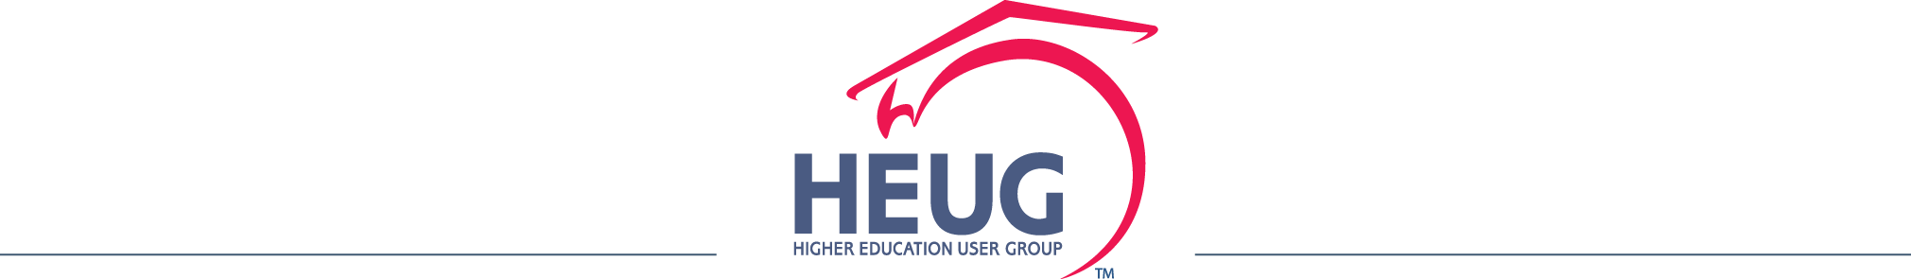

Survey Results: Campus Solutions 9.2 – Member Institutions’ Plans

Copyright © 2015 by the Higher Education User Group, Inc.
All Rights Reserved.
Survey Results: Campus Solutions 9.2 – Member Institutions’ Plans Survey
November 2015

Introduction
Oracle PeopleSoft Campus Solutions Statement of Direction 2015 – 2016 provided details of the strategic direction of Campus Solutions 9.2, including details of PeopleSoft Selective Adoption with the PeopleSoft Update Manager (PUM) and Fluid, for a new user experience. In addition to that, Oracle is providing a series of webcasts to help with understanding the existing capabilities of Campus Solutions and what to expect with 9.2. This survey was intended to find out what an institution’s plans are in respect of moving to Campus Solutions 9.2.

Respondents per Region:

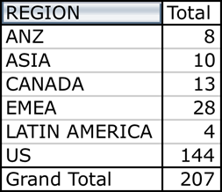

Is your institution planning to move to CS 9.2?

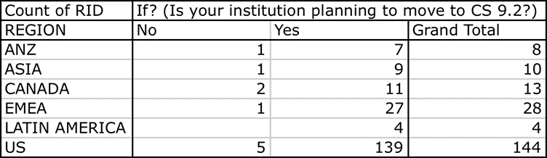

If yes, when is the project scheduled for?

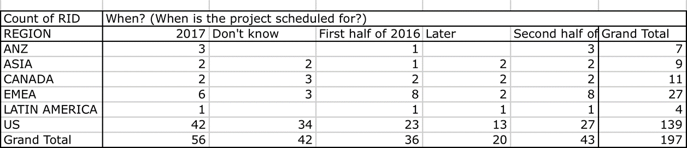

How long is the project expected to take?

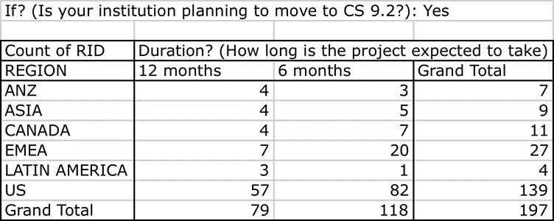

If it is expected to take longer than 12 months, please provide details below (responses anonymized):

- 18 Months - using the opportunity to review customisations.
- 2 years.
- 4 month initial technical upgrade to 9.2 then a 12 month functional upgrade at the end of 2016.
- 6 to 8 months.
- When we do our upgrade, it will be a project for all 22 production instances in our shared data center.The normal upgrade time line for all campuses is around 3 years.
- At least 6 months - maybe 9 months depending on the scope.
- Cannot determine as there is lack of support to manage patch upgrades.
- Circa 2 years.
- Details are being developed,nothing concrete as of to date (9/02/2015).
- Experience to date would advice erring on the side of caution with an upgrade of this nature.
- Given that we are current on 9.0 maintenance we understand it is supposed to be a minimal effort. If we decide to turn on new features, it may run longer. So, at this point "Don't know" would be the answer.
- Haven't developed a project plan yet, which would be tough to do with the amount of information we have now. 2017 is an educated guess. I'm hoping that the upgrade will take much less than 6 months based on the information from Oracle.
- I would expect between 6 and 12 months, but we need to upgrade our tools version from 8.53 to 8.55 as well.
- I would say tentative at this time Second Half of 2016: So far we planned next year for 9.2 but there are no definite plan in place as of this moment. We might want to do bundles up to date in the first half. Then focus on 9.2 toward the end of the year 2.
- If necessary, 18 months, dependent on complexities / issues with Initial Pass, PeopleTools upgrade if needed, and amount of retrofit work of customization if needed. When the product and upgrade scripts are released, we will be in a better position.
- It may likely take us 12-18 months due to resources restrictions.
- Not sure at this point what the duration would be.
- Our project involves CRM, Campus, interact hub, BPM and SOA.
- Our project may last longer, due to direction from executive leadership to remove as many customizations as possible, utilize delivered functionality wherever possible, and revamp business processes to align with delivered functionality.
- Project could be longer than 12 months depending on whether the project turns into a re-implementation instead of an upgrade. It's our opportunity to examine delivered functionality and consider its deployment, but also to re-evaluate other design decisions.
- The actual CS9.2 upgrade doesn't drive a 12 month project, it's other related tasks that push out the timeline, e.g., retiring major enhancements for delivered functionality.
- The project duration will be largely determined by the amount of required business process change.
- The University is looking to extend the upgrade to be a full re-implementation of Campus Solutions which will incorporate significant business change looking across the full student journey which will include the review of other associated systems.
- There is a long window between HR and Finance converting to 9.2 and the Campus Solutions conversion. They have their release details and were not on a continuous improvement module so they need to go ahead before us.
- This will happen, hopefully, in 2018. We are one of five schools in a shared instance-all must make the conversion at the same time.
- Typically an upgrade is a 9 months process, but really need to see the details of the upgrade process.
- Unsure, Our upgrade will also include upgrading pt 8.55 so we can take advantage of fluid features coming in the bundles.
- We are deploying 9.1 at this moement which is a project of 6 months. We plan eventually to upgrade all modules including HR and Finance in the future which is undertermined yet.
- We are having a complete turnover in PeopleSoft IT staff (and university IT infrastructure will be under new leadership and rebuilding).
- We are still determining dates/time-frame; currently looking at starting in 2017 with a June 2018 go-live.
- We do not have an estimate at this time.
- We expect this to be a 18-24 month project to take advantage of the transformative changes in V 9.2.
- We really don't see the value until we can show people the fluid pages. We split our HR and SA DB's and unfortunately hat campus really didn't see any value from the effort. For future efforts it is incumbent upon us show how what we do and the systems
- We would like to combine it with Tools 8.55 upgrade, so it might take longer.
- We're aiming for 9 months, actually.

What are the drivers for your institution moving to CS 9.2?

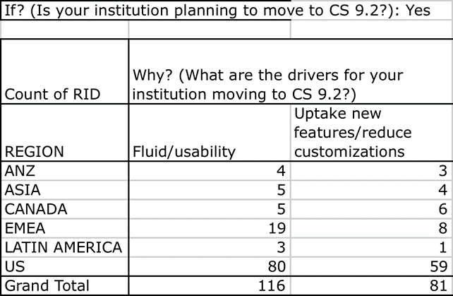

Other drivers (responses anonymized):

- A need to be on the latest version before implementing / on-boarding another 14,000 student institution as part of our institutional system. Currently have Campus Solutions for 3 campuses / institutions and now a Banner campus needs to be converted.
- Actually, the answer to Why is both Uptake new feature/reduce customizations AND Fluid/usability, but the main driver is the new features and reduce customizations.
- Also for PUM.
- Also to remain current with the product.
- At some point, we're going to have to. We know that 9.0 won't be getting as much attention as we get closer to 2020, so this seemed like the right time as we didn't want to be too much on the bleeding edge. Target go-live is January 2018.
- Because we have to keep up with Oracle's latest releases.
- Because we know support of and development for 9.0 will not continue. We've found that staying current with our PeopleSoft products is required in order to avoid bugs and other issues that come with falling behind.
- Better long-term path. We expect to be on campus solutions (and peoplesoft in general) for at least the next 10 years.
- Both fluid and uptake new features. As well as revisit functional areas of concern, e.g., Program enrolment, Gradebook.
- Both of the above apply. We'd like to put Fluid self service pages to use asap. We are also looking forward to new features that will mostly be provided by new tools. We carefully follow all communication from Oracle, and it's frustrating how vague Oracle is.
- Both really.
- Business standardisation, reduced support costs, increased efficiency, improved user experience.
- Compliance Reasons since Campus Solutions 9.0 will no longer be supported.
- Extended support for CS 9.0 ends in 2019.
- Fluid & PUM Flexibility.
- Fluid is also a major driver. PUM - ability to have better control over the patch/fix cycle. Desire to be on a comparable release level across HCM, Finance and Campus.
- Fluid, forms, and the opportunity to reduce customizations are all important to us. (I speak for Admissions & Records.) However, we don't have enough information to be able to assess customizations at this point. Last week's product webinar was disappointing.
- Fluid, Usability, More options with the later tools release.
- Fluid/usability.
- In order to remain in compliance and on a vendor supported platform an institution has to either upgrade to a supported platform or change product lines. There is about a 99% chance that we will be ying with PeopleSoft Campus Solutions.
- It's both Fluid and the uptake of new features (reduce customisations), but the latter is the more important of the two.
- It's required in order to receive ongoing support of the product.
- Keep current.
- Keep support and receive new features.
- Licensing/support.
- Mandatory to assure long term support
- Move to a version with a longer support window than 9.0.
- Oracle said we have to for continued support...
- Our institution is part of a system-wide shared services model and the move is being determined for us.
- Path and timing depends on data from others as they migrate. Not one to be on the bleeding edge, need clear and concise information to facilitate decisions.
- PUM.
- PUM implementation so that we don't have to do 4 bundles a year impacting all of campus.
- Responsive design for mobile access is a plus.
- Start using PUM.
- Stay current.
- Stay current. PUM / selective adoption. Hard to say otherwise since we have no idea what level of new features 9.2 will be providing.
- Staying current with technology.
- Support. Compatibility with other suites: HCM & FMS
- The fields above was in default values. But we would like to request Oracle to keep up SEVIS batch updates for F and J.
- The main driver is to maintain continued Oracle support. Fluid/New Features/Reduce Customizations will all be included in our project.
- The primary driver would be to stay current on Campus Solution maintenance / version.
- The push is really from HR and Finance who want to move to 9.2 and we want to keep all databases on the same release. Also, to stay current and keep maintenance in place.
- This upgrade will be an opportunity to thoroughly review all new features introduced over the years that we haven't had a chance to review due to the need to keep up with the patch schedule.
- To ensure that the College does not need to acquire Extended Support for any of our Oracle software products.
- To sat as current as possible with versions and functionality.
- To use the tools delivered.
- UI, UI, and UI.
- Update of Tools (8.54..8.55).
- Upgrade Manager, we are already reviewing several of the new features offered as a result of the Continuous delivery cycle, such as Student Activity guides and we reviewed Program Enrollment as well, but have not been able to take advantage of many thus far.
- Uptake new features.
- Usability is a great motivator for the change but we also want to implement new features and functionalities. We won't know if we can reduce customizations until we know all the details about the structures of the application in relation to the modules.
- We are currently on Tool 8.54.xx and bundles up to #37 so we are fairly current on features but with 9.2 there will be additional features and yes we will gain value of them as a result of the upgrade but to enable the users with a richer experience on al…
- We are eager to have access to some of the newer enterprise components that were formerly in the HR code line such as AWE. We also just want to be more in line with the latest releases. We would upgrade sooner except that we are actively implementing four
- We are very interested in all the functionalities for students and teachers with the latest fluid possibilities. Also PEAM has to work well for both of our institutions .
- We do want to take the time and look at the new features already delivered.
- We have to keep up to use the tools. forced migration by Dec 2019 or we lose support, right?
- We plan to implement 9.2 in the middle of our overall Campus Solutions implementation, which we're putting in place for fall 2016.

Conclusion

Thank you to the members who took the time to complete this survey! The responses have provided a great insight into the schedule for upgrading to CS 9.2 across the community.

Jane Broad
HEUG, Executive Vice President of Product
University of Glasgow

