Step 1: Backup CA and PUM Image metadata.

Export all the change packages previously created from past images:

Open the current Change Assistant. From tools, select “Migrate Customer data”.
Make sure the PUM source is pointing to most current source. Check all data types. Export to folder: D:\CA_backup\packages\CustomerData
File: customerdata_FSXX.DAT (use the app and image source number)

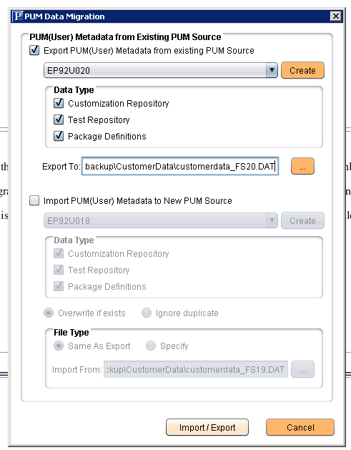

Backup CA settings:
Go to Tools > Export/Import CA Settings

Export path: D:\CA_backup\FullSystemSettings
File name: casetting_<current-date>.zip

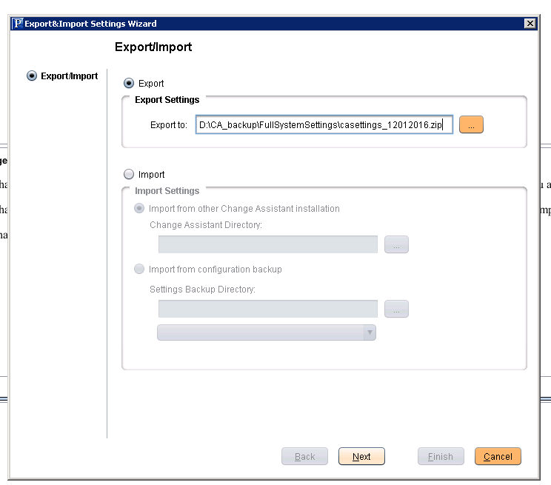

Check the most recent Database and click next
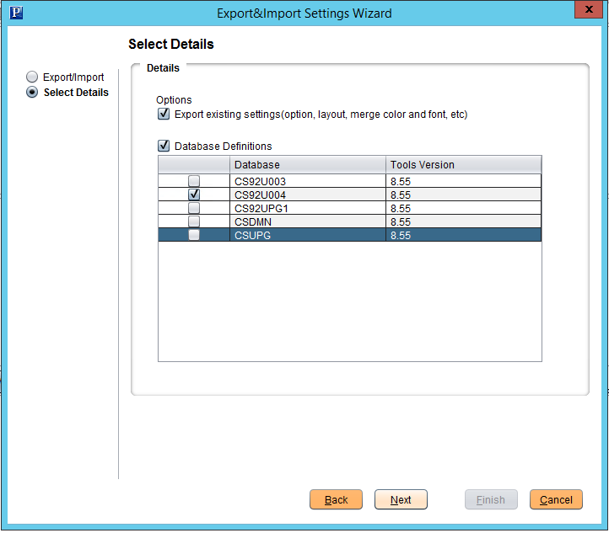

CA backup completed.

